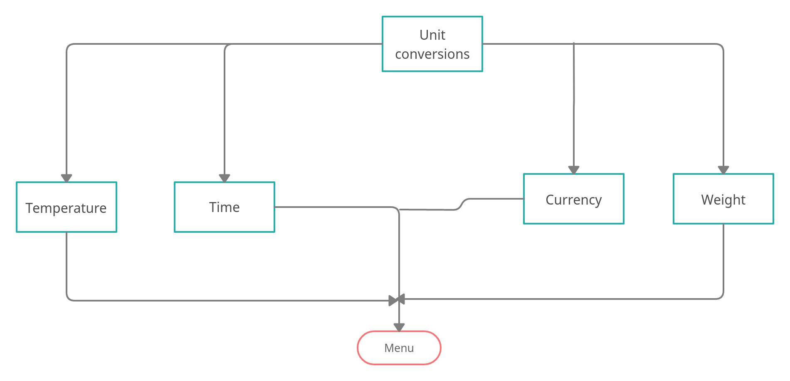
Structural Diagrams of Unit conversions

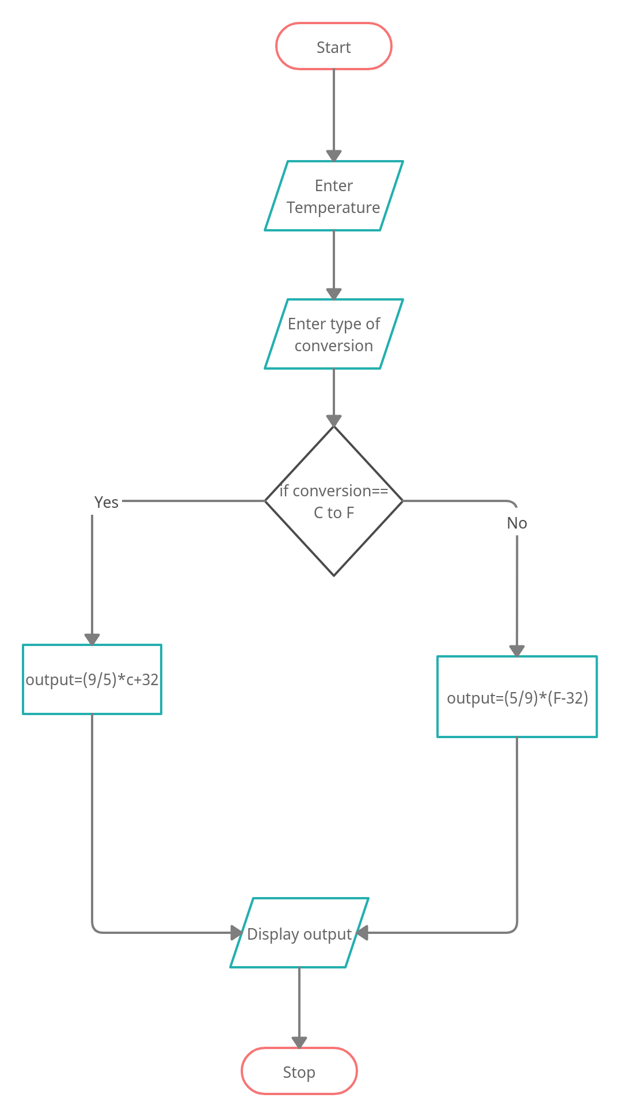
Behavirol diagram of temperature conversion

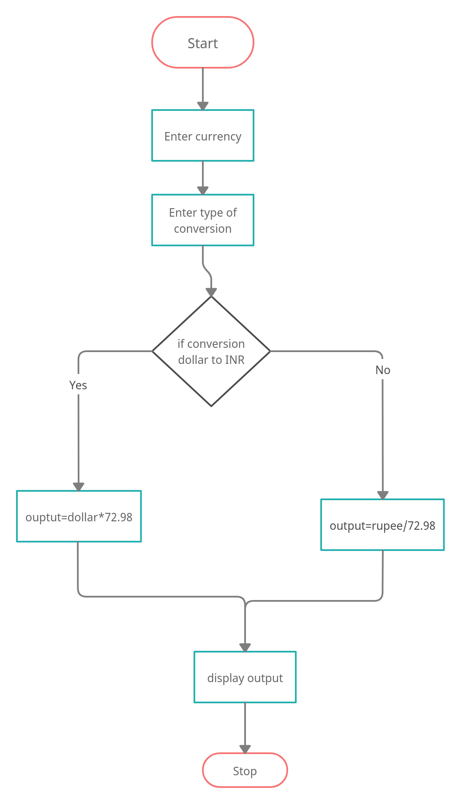

Behavirol diagram : CURRENCY CONVERSION

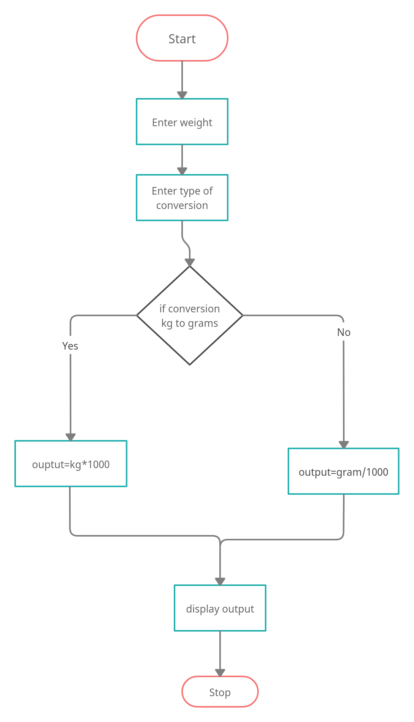

Behaviroul Diagram:Weight convertion

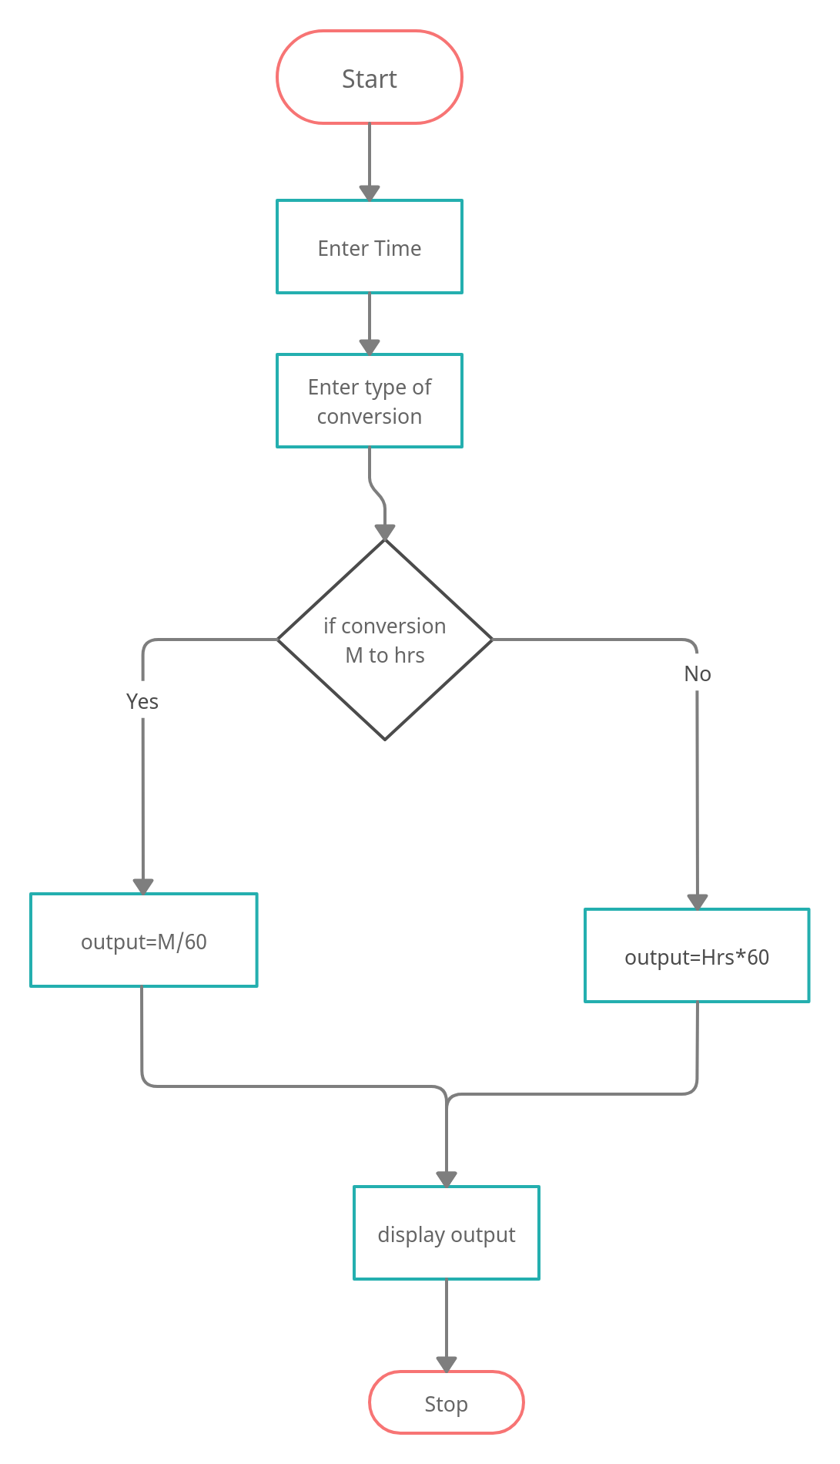
Behavirol diagram: Time conversion

